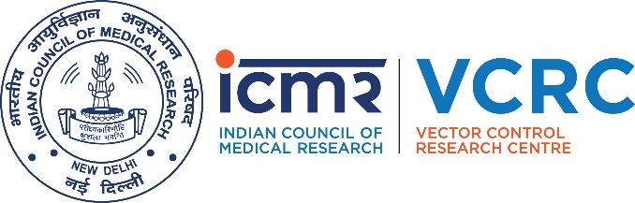

ICMR-VECTOR CONTROL RESEARCH CENTRE
MEDICAL COMPLEX, INDIRA NAGAR
PUDUCHERRY-605 006
Phone No.0413-2272396, 2272397, Fax No.2272041
Email: vcrc@vsnl.com Website: (www.vcrc.res.in)

ADVERTISEMENT NO.09/PROJECT/2019 DATED 16.05.2019

WALK-IN-WRITTEN TEST/INTERVIEW

The following post is to be filled purely on temporary basis from willing eligible candidates in the ad-hoc research project entitled“MOLECULAR ECOLOGY OF Aedes aegyptiIN INDIA: ELUCIDATING GENETIC STRUCTURE, DISPERSAL POTENTIAL AND CONNECTIVITY AMONG POPULATIONS” in ICMR-VCRC Field Station, Chinna Chokkikulam, Madurai funded by SERB-DST, Government of India.

Selection Procedure: Walk-in-Interview and/or a Written Test, if the numbers of eligible candidates are more than 30, will be conducted after verification of the original certificates.

Name of the post | Junior Research Fellow (JRF)
Number of Post | 01 (One) – UR:01
Place of Posting | Madurai
Essential Qualification | PG degree in Life Science/Biochemistry/Biotechnology/MolecularBiology/ Bioinformatics
Fellowship | `25,000/- + HRA as admissible
Age limit | 30 years
Contract period | One Year
Venue  Date of Walk-in-Written Test/Interview  Reporting time | ICMR-Vector Control Research Centre Field Station  No. 4, Sarojini Street, Chinna Chokkikulam, Madurai – 625 002  31.05.2019 (Friday)  09.00 A.M to 10.00 A.M (Candidates will not be entertained after 10 A.M)  (Written test/Interview from 10.30 onwards)

I. Other Information:

- Candidates who wish to appear for the above can download the Application Form from the Website of ICMR-Vector Control Research Centre (www.vcrc.res.in). Candidates are requested to fill the application form and bring all the original certificates of educational qualifications (Certificate/Statement of marks), experience certificates, Aadhaar Card,along with one set of Xerox of the same duly self-attested along with a recent passport size photograph for attending the Written Test/Interview.

- Qualification will be reckoned as on the date of Walk-in-Written Test/Interview.

- Mere fulfilling the essential qualification does not guarantee for the selection.

- Person already in regular time scale service under any Government Department/Organizations are not eligible to apply.

- The selected candidates will be appointed purely on temporary basis initially for a period of one year and extendable upto three years maximum or till the completion of the project.

- Appointment may be extended depending on the satisfactory work performance as assessed by the Principal Investigator or till the validity of the project, or whichever is earliest.

- The selected candidate will directly report to the Principal Investigator regarding his/her work progress and project related matters.

- The service will be governed as per rules of ICMR.

- No TA/DA etc. will be paid to the candidate for appearing in walk-in- written test or interview.

- The selected candidate will have no claim for regular appointments in any ICMR Institutes/Centres for continuation of his/her services in any other project.

- The selected candidate are entitled for leave as per ICMR guidelines.

- Any canvassing by or on behalf of the candidate or bringing political or other outside influence with regard to selection shall be a disqualification and such candidates will not be entertained.

- The Director, ICMR-VCRC has the right to accept/reject any application without assigning any reason(s) and no correspondence in this matter will be entertained.

II. GENERAL INSTRUCTIONS:

- Candidates are required to be present at the venue in time and the Walk-in Written Test/Interview will commence after verification of all the original certificates.

- No calculators, log tables, communication devices like cell- Phone (Mobile), Tablet/iPad etc. are allowed inside the examination hall.

- Request for revaluation of Answers will not be entertained.

- Candidates who resort to malpractice of any kind will immediately be sent out of the Examination Hall.

PRINCIPAL INVESTIGATOR

