IFGTB MTS Recruitment 2019 – 15 Multi Tasking Staff (MTS) & LDC
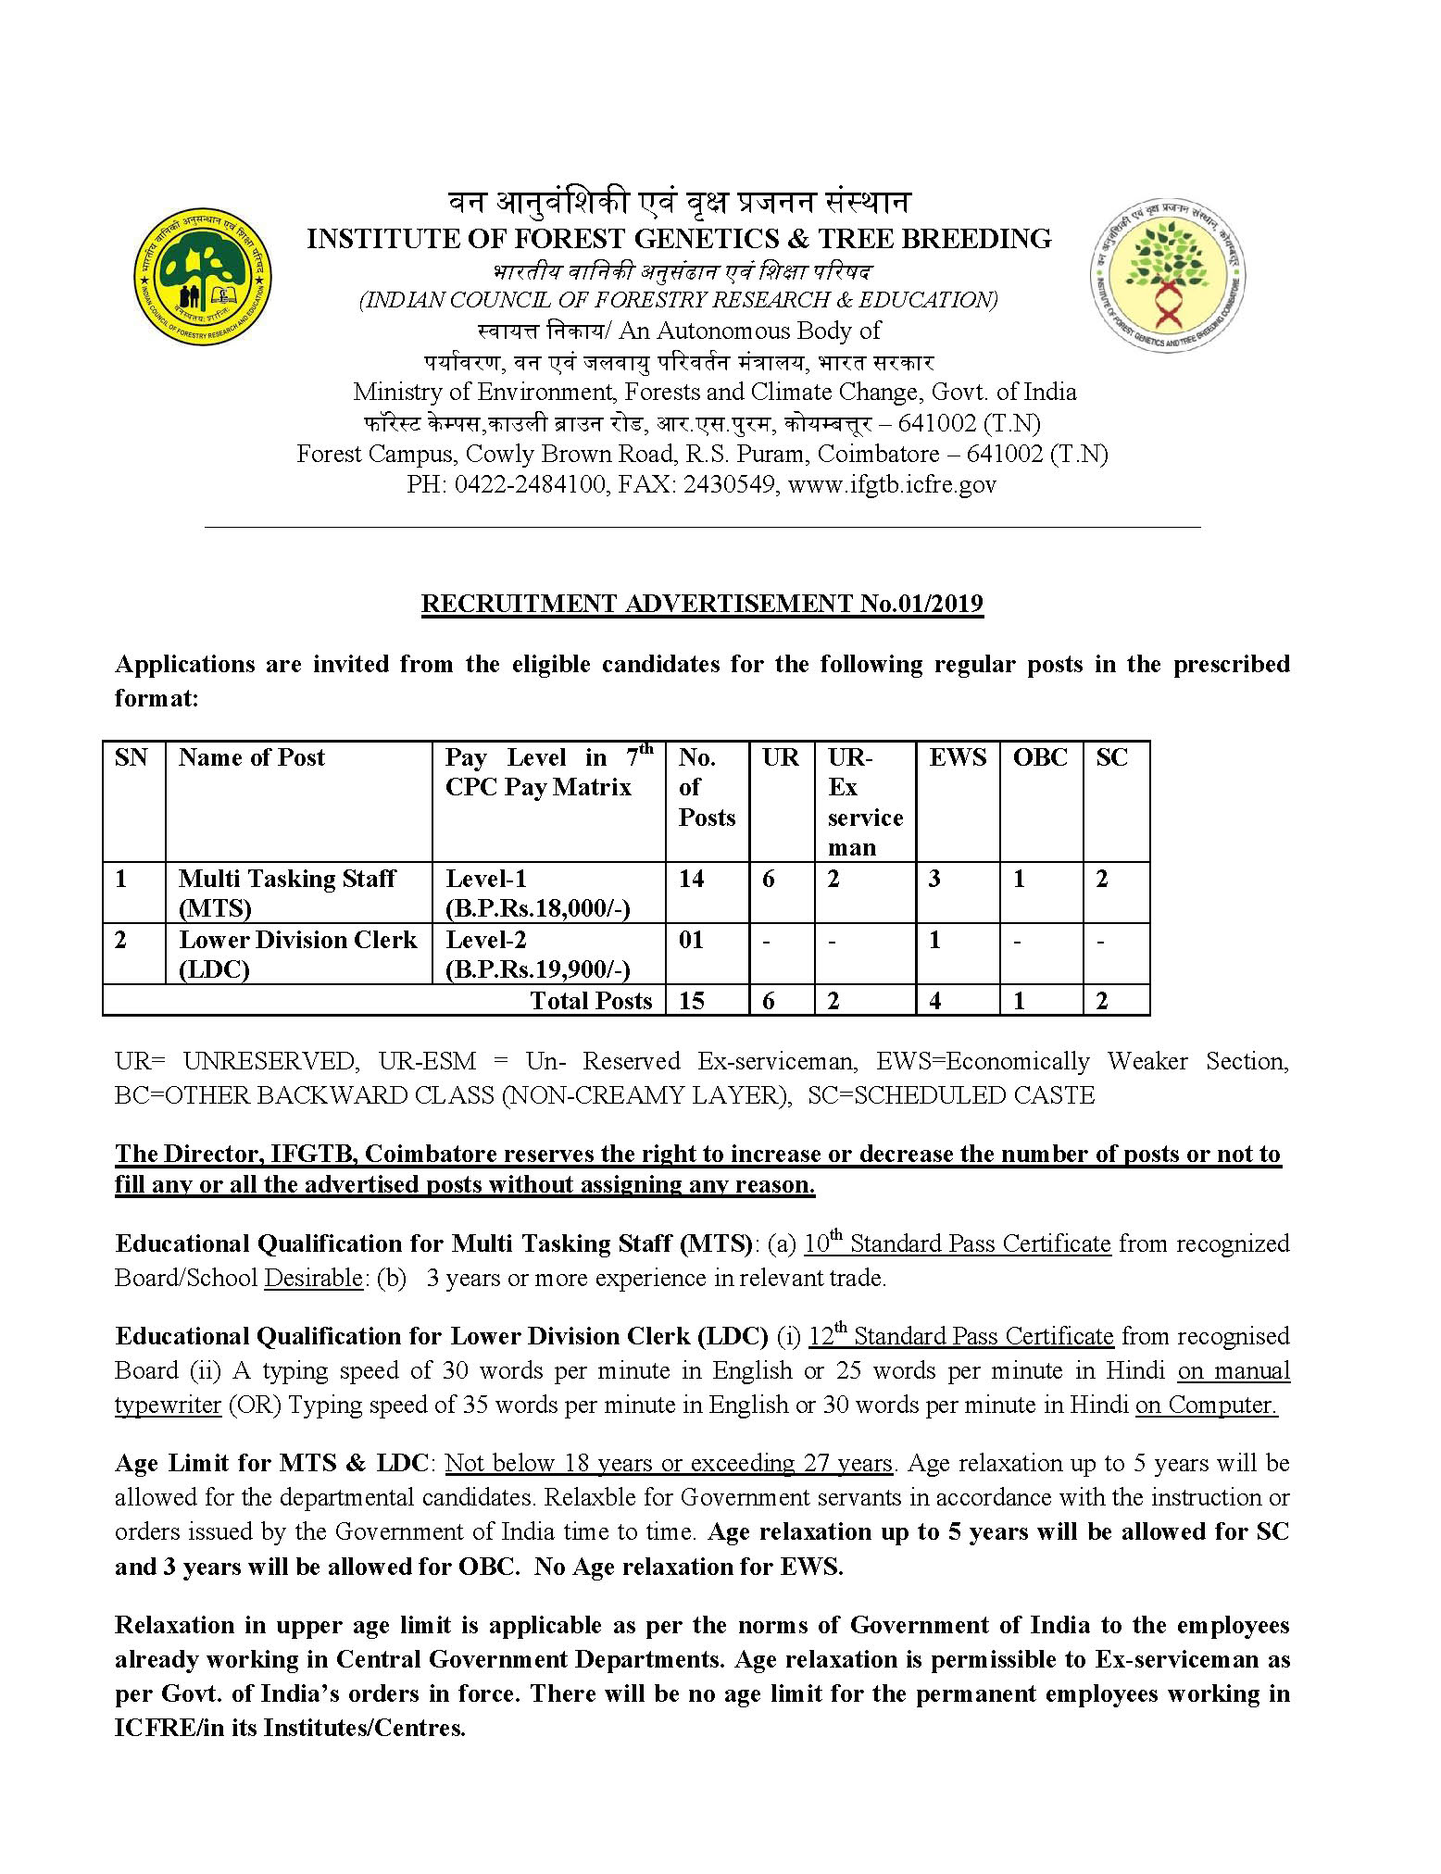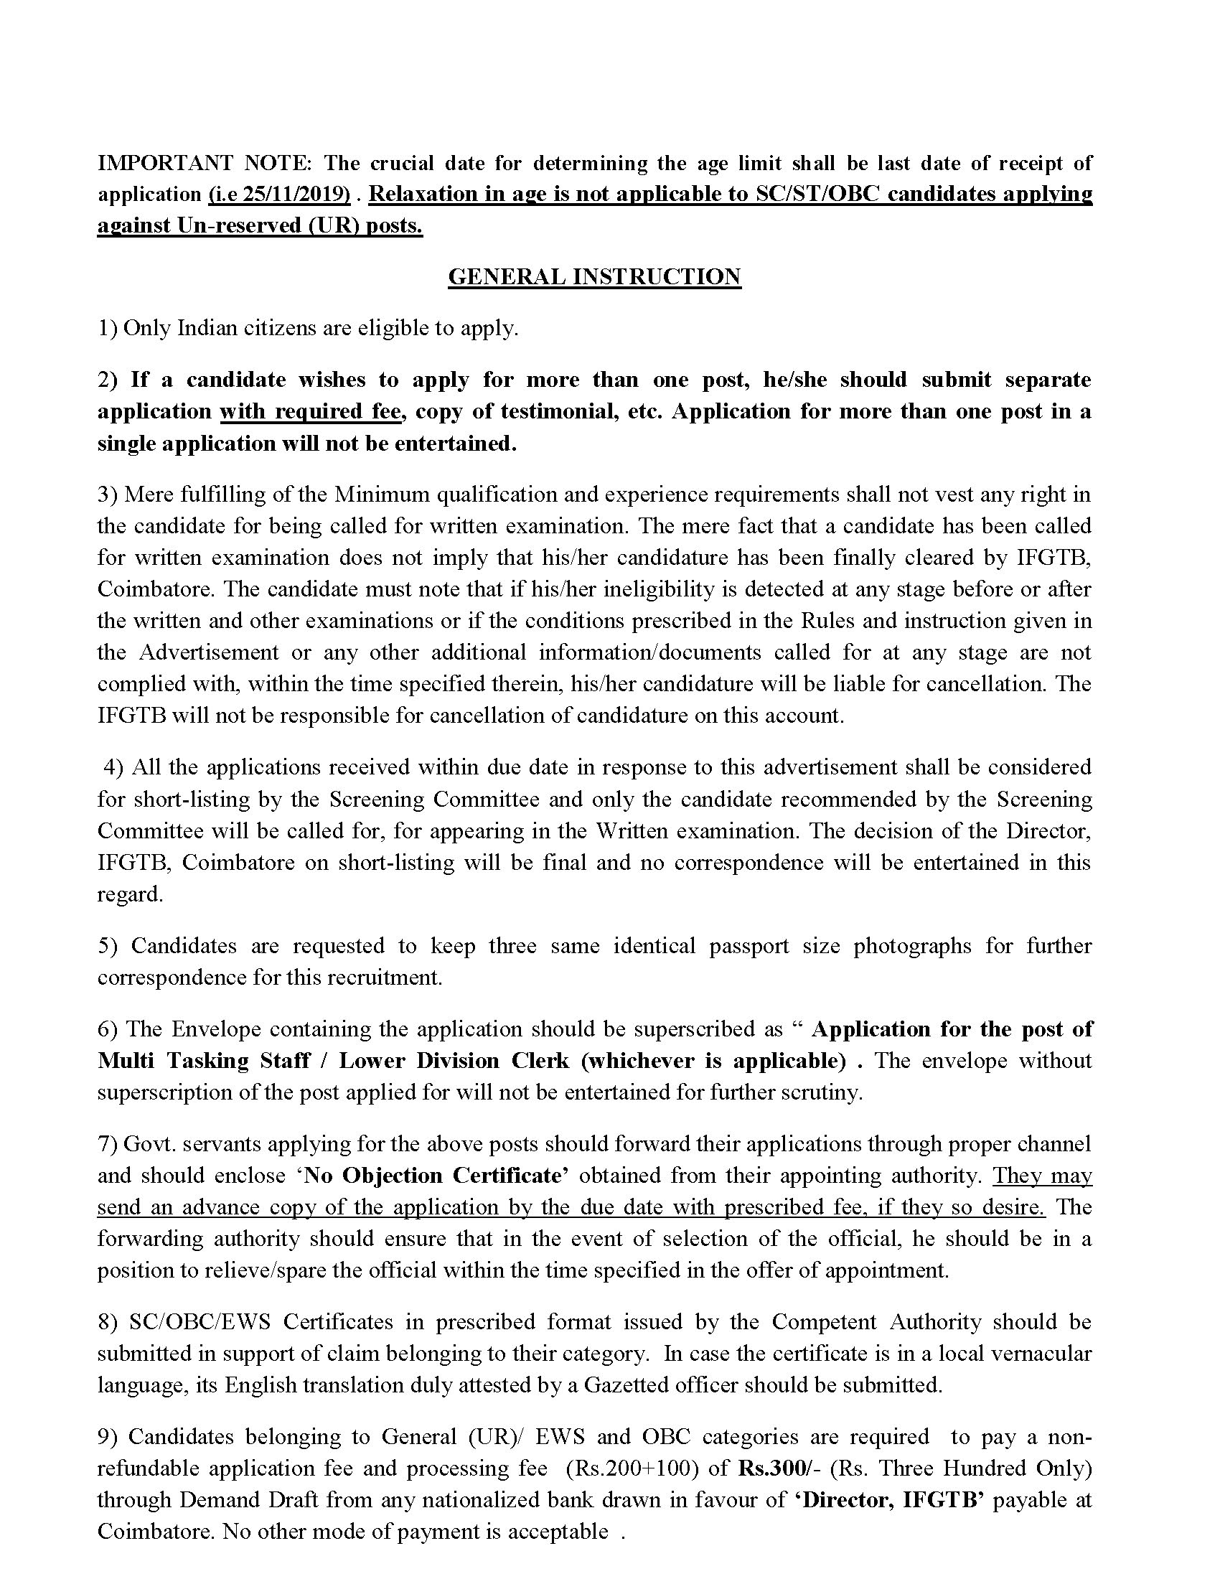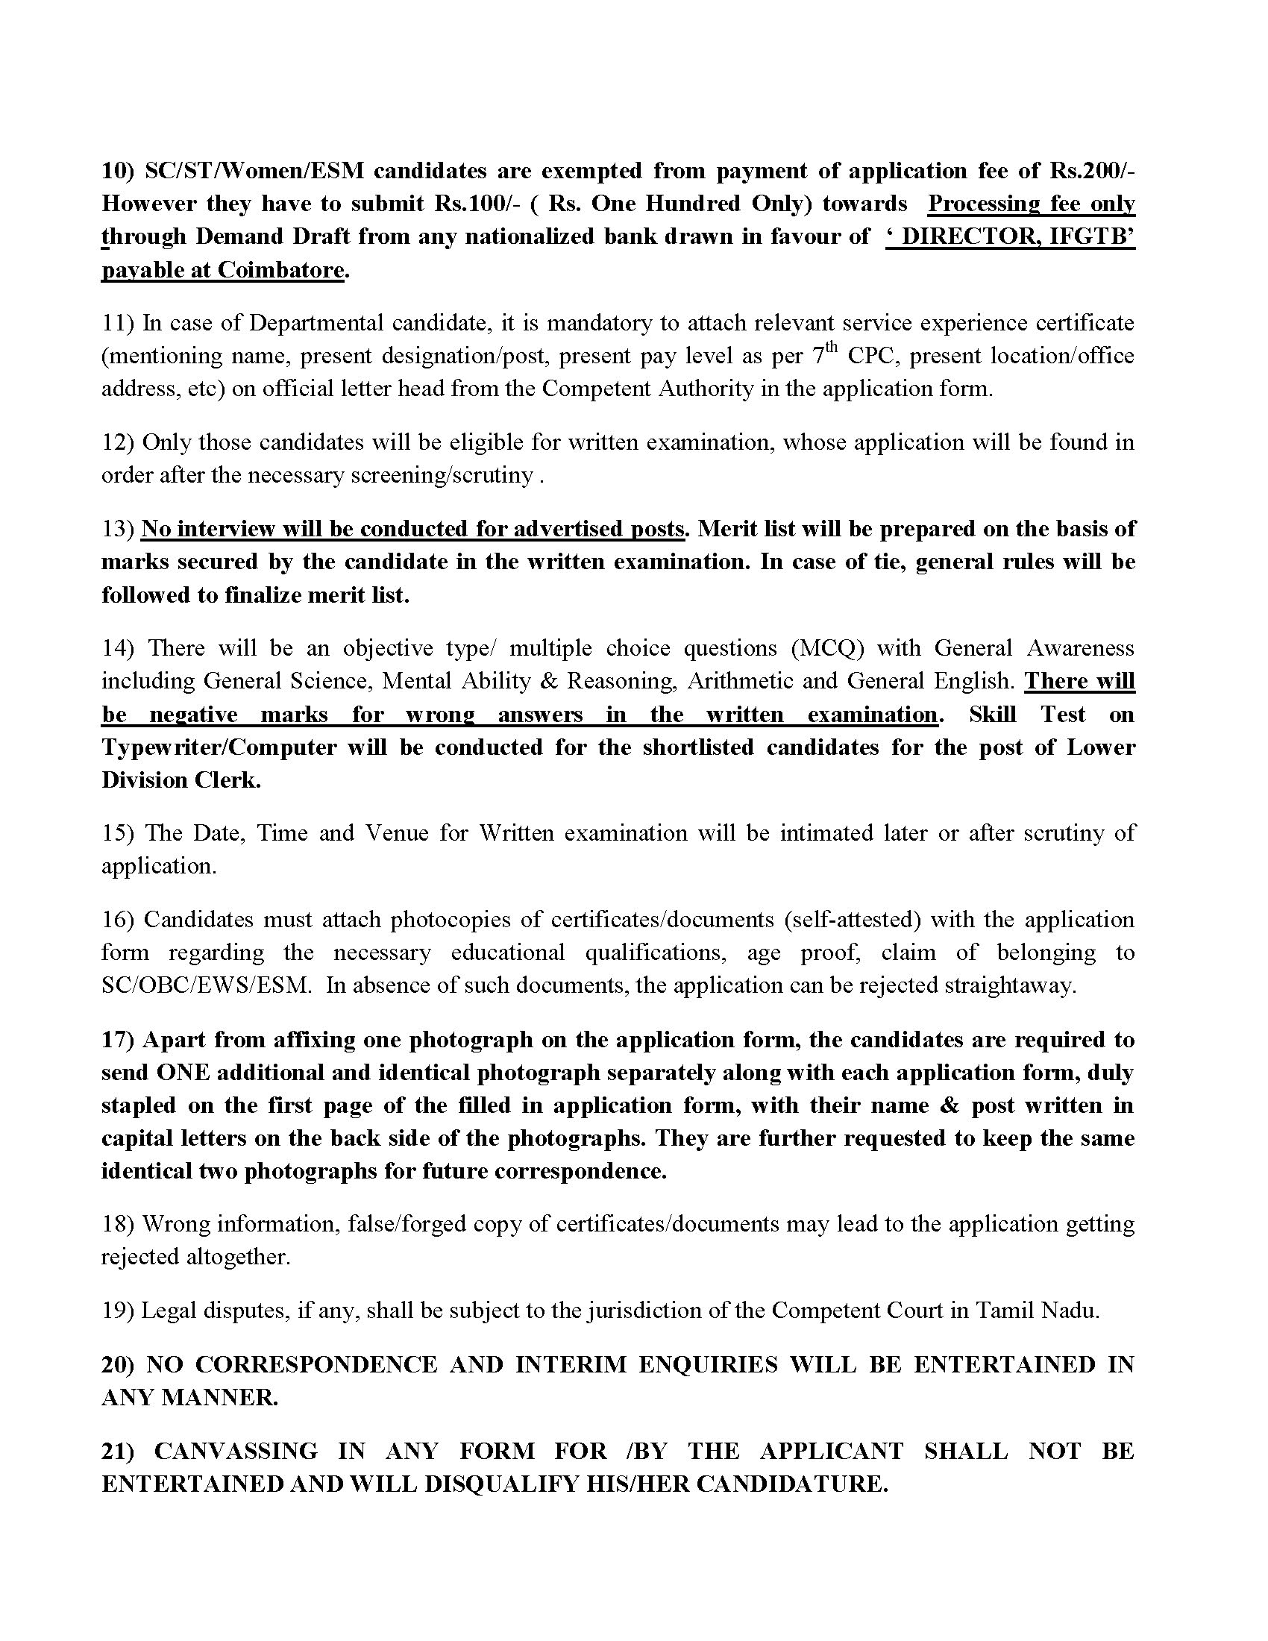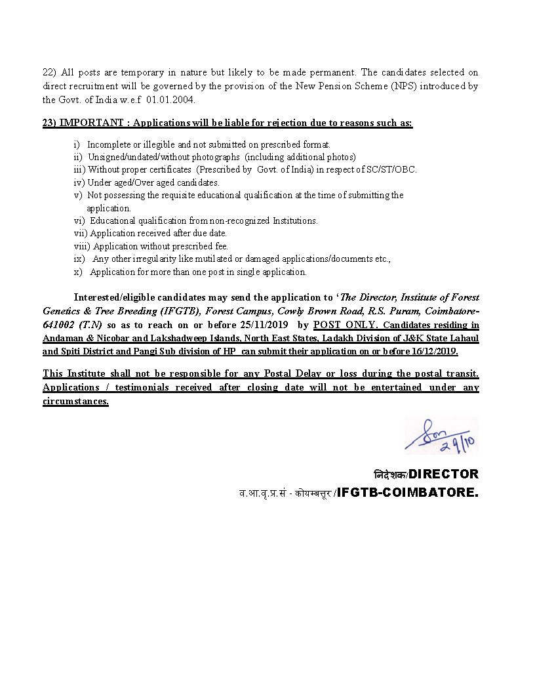

वन आनुवंशिकी एवं वृक्ष प्रजनन संस्थान
INSTITUTE OF FOREST GENETICS & TREE BREEDING
भारतीय वानिकी अनुसंढान एवं शिक्षा परिषद
(INDIAN COUNCIL OF FORESTRY RESEARCH & EDUCATION)
स्वायत्त निकाय/ An Autonomous Body of
पर्यावरण, वन एवं जलवायु परिवर्तन मंत्रालय, भारत सरकार
Ministry of Environment, Forests and Climate Change, Govt. of India
फॉरेस्ट केम्पस,काउली ब्राउन रोड, आर.एस.पुरम, कोयम्बत्तूर – 641002 (T.N)
Forest Campus, Cowly Brown Road, R.S. Puram, Coimbatore – 641002 (T.N)
PH: 0422-2484100, FAX: 2430549, www.ifgtb.icfre.gov _____________________________________________________________________________

Application for the post of Multi Tasking Staff : Advt. No.01/2019
Paste Recent Passport size Self attested Photograph
- Full Name (In Block Letters) : ______________________________________
- Father’s/Husband’s Name : ______________________________________
- Nationality : ______________________________________
Male | Female
- Gender (Please put tick mark ) :
- Permanent Address : _______________________________________
(In Block Letters) _______________________________________
_______________________________________
_______________________________________
State:_________________Pincode:___________
- Address for Communication : _______________________________________
(In Block Letters) _______________________________________
_______________________________________
_______________________________________
State:_________________Pincode:___________
- Mobile No. :1)____________________________________
2)_____________________________________
- E-mail ID : _______________________________________
- Aadhar No. : _______________________________________
UR | UR-Ex-SM | EWS | OBC | SC
- Category(Please put tick mark) :

- Date of Birth : ______________________________________
- Age as on closing date ( 25/11/2019) : ________ Years _______ Months _______Days
- Whether age relaxation claimed, if so _______________________________________
Indicate the category (attach copy of Certificate)
( Continued...2)
-(2)-
- Details of Demand Draft:
AMOUNT | NAME OF BANK&BRANCH | D.D. No. | D.D. Date

- Educational Qualification :
(attach self attested copy of certificates):
S  N | Exami-  nation  Passed  (SSLC  onwards) | Name of Board/  University | Month& Year of Passing | Subjects  ( Major) | Marks obtained /Total  Marks | % of  Marks
1
2
3
4
5
6

- Experience , if any

S  N | Post Held | Name of the employer | Period |  | Pay Scale | Remarks
 |  |  | From | To
1
2

- Whether the candidate is under any contractual obligation to serve Central/State Govt./Any other Public Sector Undertakings or Autonomous Body and if so, give details ( attach No objection Certificate): _____________________________________________________

- List of Documents Attached ( self-attested):
(1) _________________ (2)___________________(3)_____________________
(4) _________________ (5) __________________ (6) _____________________

DECLARATION

I hereby declare that all the facts mentioned in this application are true, complete and correct to the best of my knowledge and belief. I understand that in the event of any information being found false or incorrect at any stage or not satisfying the eligibility criteria according to the requirements of the relative advertisement, my candidature/appointment is liable to the cancelled/terminated.

Place:__________________ (Signature of the applicant)

Date: __________________ Name of the Applicant:__________________
वन आनुवंशिकी एवं वृक्ष प्रजनन संस्थान
INSTITUTE OF FOREST GENETICS & TREE BREEDING
भारतीय वानिकी अनुसंढान एवं शिक्षा परिषद
(INDIAN COUNCIL OF FORESTRY RESEARCH & EDUCATION)
स्वायत्त निकाय/ An Autonomous Body of
पर्यावरण, वन एवं जलवायु परिवर्तन मंत्रालय, भारत सरकार
Ministry of Environment, Forests and Climate Change, Govt. of India
फॉरेस्ट केम्पस,काउली ब्राउन रोड, आर.एस.पुरम, कोयम्बत्तूर – 641002 (T.N)
Forest Campus, Cowly Brown Road, R.S. Puram, Coimbatore – 641002 (T.N)
PH: 0422-2484100, FAX: 2430549, www.ifgtb.icfre.gov _____________________________________________________________________________

Application for the post of Lower Division Clerk : Advt. No.01/2019
Paste Recent Passport size Self attested Photograph
- Full Name (In Block Letters) : ______________________________________
- Father’s/Husband’s Name : ______________________________________
- Nationality : ______________________________________
Male | Female
- Gender (Please put tick mark ) :
- Permanent Address : _______________________________________
(In Block Letters) _______________________________________
_______________________________________
_______________________________________
State:_________________Pincode:___________
- Address for Communication : _______________________________________
(In Block Letters) _______________________________________
_______________________________________
_______________________________________
State:_________________Pincode:___________
- Mobile No. :1)____________________________________
2)_____________________________________
- E-mail ID : _______________________________________
- Aadhar No. : _______________________________________
- Category ( Attach Proof :_____________________________________
- Date of Birth : ______________________________________
- Age as on closing date ( 25/11/2019) : ________ Years _______ Months _______Days
- Whether age relaxation claimed, if so _______________________________________
Indicate the category (attach copy of Certificate)
( Continued...2)

-(2)-
- Details of Demand Draft:
AMOUNT | NAME OF BANK&BRANCH | D.D. No. | D.D. Date

- Educational Qualification :
(attach self attested copy of certificates):
S  N | Exami-  nation  Passed  (SSLC  onwards) | Name of Board/  University | Month& Year of Passing | Subjects  ( Major) | Marks obtained /Total  Marks | % of  Marks
1
2
3
4
5
6

- Experience , if any

S  N | Post Held | Name of the employer | Period |  | Pay Scale | Remarks
 |  |  | From | To
1
2

- Whether the candidate is under any contractual obligation to serve Central/State Govt./Any other Public Sector Undertakings or Autonomous Body and if so, give details ( attach No objection Certificate): _____________________________________________________

- List of Documents Attached ( self-attested):
(1) _________________ (2)___________________(3)_____________________
(4) _________________ (5) __________________ (6) _____________________

DECLARATION

I hereby declare that all the facts mentioned in this application are true, complete and correct to the best of my knowledge and belief. I understand that in the event of any information being found false or incorrect at any stage or not satisfying the eligibility criteria according to the requirements of the relative advertisement, my candidature/appointment is liable to the cancelled/terminated.

Place:__________________ (Signature of the applicant)

Date: __________________ Name of the Applicant:__________________
ANNEXURE-I

(In the case of Govt. employees)
Certificate to be furnished by the Employer / Forwarding Authority

Certified that:

- The particulars furnished by Shri /Smt. are correct.

- There is no vigilance/disciplinary case either pending or contemplated against him/her.

- Integrity of the applicant iscertified.

- Photocopies of the up-to-date ACRs attested by an officer not below the rank of an Under Secretary to the Govt. of India areenclosed.

- In the event of his/her selection, there is no objection to relieve /spare him/her within the time specified in the offer ofappointment.

Date: (Signature of the Head of the Department/ForwardingAuthority)

Department / Office with seal TelephoneNo.

ANNEXURE-II

FORM OF SCHEDULED CASTE / TRIBE CERTIFICATE

This is to certify that Shri/Shrimati*/Kumari* son/daughter* of village/town* in District/Division*
of the State/Union Territory*

belongstothe Caste/Tribe which is recognized as a Scheduled Caste/Scheduled Tribe*under:
*The Constitution (Scheduled Castes) Orders, 1950: *The Constitution (Scheduled Tribes) Order, 1950; *The Constitution (Scheduled Tribes) (Union Territories) Order, 1950; *The Constitution (Scheduled Tribes) (Union Territories) Order, 1951: {as amended by the Scheduled Castes and Scheduled Tribes List (Modification Order, 1956, the Bombay Recognisation Act, 1960, the Punjab Recognisation Act, 1966, the State of Himachal Pradesh Act, 1970, the North Eastern Areas (Recognisation) Act, 1971 and the Scheduled Castes and Scheduled Tribes Orders (Amendment) Act, 1976} *The Constitution (Jammu and Kashmir) Scheduled Order, 1956; *The Constitution (Andaman and Nicobar Islands) Scheduled Tribes Order, 1959 as amended by the Scheduled Castes and Scheduled Tribes Orders (Amendment) Act, 1976; *The Constitution (Dadra and Nagar Haveli) Scheduled Castes Order, 1962; *The Constitution (Dadra and Nagar Haveli) Scheduled Tribes Order, 1962; *The Constitution (Pondicherry) Scheduled Castes Order, 1964; * The Constitution (Scheduled Tribes) (Uttar Pradesh) Order, 1967; * The Constitution (Goa, Daman and Diu) Scheduled Castes Order, 1968; * The Constitution (Goa, Daman and Diu) Scheduled Tribes Order, 1968; * The Constitution (Nagaland) Scheduled Tribes Order, 1970. *The Constitution (Sikkim)ScheduledTribesOrder,1978.*Theconstitution(JammuandKashmir)ScheduledTribesOrder,1989.
*The constitution (Scheduled Castes) Orders (Amendment) Act, 1990. *The Constitution (Scheduled Tribes) Orders, amendment Act, 1991. *The Constitution (Scheduled Tribes) order Second Amendment Act,1991.

  - This certificate is issued o the basis of the Scheduled Castes/Scheduled Tribes Certificate issuedto

Shri/Shrimati*/Kumari* father/mother of

Shri/Shrimati/Kumari of village/town in

District/Division of theState/UnionTerritory who belongs to the Caste/Tribe which is recognized as Scheduled Caste/Scheduled Tribe in the State/UnionTerritory
issuedbythe dated .

  - Shri/Shrimati/Kumari and or his/her familyordinarily

reside(s)in village/town of District/Division of the

State/UnionTerritoryof .

Signature Designation

Place
Date
(With seal of office) State/Union Territory )

ANNEXURE-III

FORM OF CERTIFICATE TO BE PRODUCED BY OTHER BACKWARD CLASSES APPLYING FOR APPOINTMENT TO POSTS UNDER THE GOVERNMENT OF INDIA

This is to certify that Shri/Smt./Kumar

son/daughter of of village/town

in District/division

in the State/Union Territory

belongs to the

community which is recognised as a backward class under the Government of India, Ministry of Social Justice and Empowerment’s Resolution
No. dated .

Shri/Smt./Kumari and /or his/her family

ordinarily reside(s) in the District/Division of the

State/Union Territory. This is also to certify that he/she does not belong to the persons/sections (Creamy layer) mentioned in Column 3 of the Scheduled to the Government of India, Department of Personnel & Training O.M. No.36012/22/93-Estt(SCT) dated 08.09.1993.
Dated: District Magistrate,
Deputy
Commissioner etc.

Seal

Appendix-1

APPLICATION FORM FOR GROUP 'C'
(Retired Defence Service Personnel)
Please paste your passport size photograph (in uniform)

1. Personnel number, Rank and Name :
2. Arm/ Service :
3. Father's Name :
4. Dates of —
(a) Birth :
(b) Enrolment :
(c) Retirement / Discharge :
5. Reasons for Release / Discharge :
6. Medical Category :
7. Award or Decoration :
8. Home, District and State :
9. Present Address/ Mailing Address :
10. Permanent Address :
11. Present profession employment :
12. Qualification: (Please attach attested copies of mark sheets)
Course | Year | Institution | Civil Equivalent
(a) Civil (Education)
(b) Military (Education)
(c) Military (Profession)

13. *Languages known - Read/Write/Speak
(a) Indian :
(b) Foreign :

*Applicable where applications are not made directly.

14. * Character as assessed by Military authorities
15. Extra-curricular activities-
(a) Sports :
(b) Literary :
(c) Cultural/Art :
16. Details of pay/pension/gratuity-
(a) Last basic pay drawn :
(b) Total emoluments :
(c) Details of pension/gratuity :
17. Zilla Sainik Board/Employment Exchanges:
(Registration No.)
18. Job applied for
Date ( ...............................................)
Signature
Name
Address

*Countersigned
_____________________________________________________________________________
* Applicable where applications are not made directly.

Appendix-2
PRO FORMA OF CERTIFICATE FOR EMPLOYED OFFICIALS
G.I., Dept. of Per. & Trg., O.M. No.36034/2/91-Estt.(SCT), Dated 03-04-1991

I hereby, with the information available, certify that Shri ................................................(Name) No.............................................. (Rank) would complete prescribed period of appointment on ..................................(Date)
Place: Signature
Dated: Commanding Officer
Office Seal
Appendix-3
FORM OF UNDERTAKING TO BE GIVEN BY CANDIDATES APPLYING FOR CIVIL POSTS UNDER EX-SERVICEMEN CATEGORY
G.I., Dept. of Per. & Trg., O.M. No.36034/2/91-Estt.(SCT), Dated 03-04-1991

I understand that, if selected on the basis of the recruitment/examination to which this application relates, my appointment will be subject to my producing documentary evidence to the satisfaction of the Appointing Authority that I have been duly released/retired/discharged from the Armed Forces and that I am entitled to the benefits admissible to ex-servicemen in terms of the Ex-Servicemen (Re-employment in Central Civil Services and Posts) Rules, 1979, as amended from time to time.
2. I also understand that I shall not be eligible to be appointed to a vacancy reserved for Ex-servicemen in regard to the recruitment covered by this examination, if I have at any time prior to such appointment, secured any employment on the civil side (including Public Sector Undertakings, Autonomous Bodies/Statutory Bodies, Nationalized Banks, etc.), by availing of the concession of reservation of vacancies admissible to Ex-servicemen.

Place: Signature of Candidate
Date:

Annexure-4
(in the case of Govt. employees)

Certificate to be furnished by the Employer / Forwarding Authority certified that :
- The particulars furnished by Shri/Smt. ______________________________ are correct.
- There is no vigilance / disciplinary case either pending or contemplated against him/here.
- Integrity of the applicant is certified.
- Photocopies of the up-to-date ACRs, attested by an officer not below the rank of an Under Secretary to the Govt. of India are enclosed.

Date : (Signature of the Head of the Department / Forwarding Authority)
Department/Office with seal
Telephone No._________________
Annexure -1
Government of …………………………………………………
_____________________________________________________
________________________________________________
(Name & Address of the authority issuing the certificate)

INCOME & ASSET CERTIFICATE TO BE PRODUCED BY ECONOMICALLY WEAKER SECTIONS

Certificate No:________________________ Date:_____________

VALID FOR THE YEAR _____________________

THIS is to certify that Shri/Smt/Kumari _________________________________________ son/daughter/wife of
______________________________ is permanent resident of ______________________________Village/
Street____________________________ Post Office ______________________ District :_________________ in
the State/Union Territory PIN CODE________________ whose photograph is attested below Economically Weaker Sections, since the gross annual income* of his/her“’family’” ** is below Rs.8 lakh(Rupees Eight Lakh only) for the financial year. His/her family does not own or possess any of the following assets***

i. 5 acres of agricultural land and above;
ii. Residential flat of 1000 sq ft and above
iii. Residential plot of 100 sq yards and above in notified municipalities
iv. Residential plot of 200 sq yards and above in acres other than the notified municipalities

2. Shri/Smt/Kumari _____________________________ belongs to the _________________________
caste which is not recognized as a Scheduled Caste, Schedule Tribe and Other Backward Classes (Central List).

Signature with seal of office…………………………………………….
Name:………………………………………………………………….
Designation:……………………………………………….
___________________________________________________________________________________________

Recent Passport size
Attested photograph of
applicant

*Note 1: Income covered all sources i.e. salary, agriculture, business, profession etc.
**Note2: The term ‘Family” for this purpose will include the person, who seeks benefit of reservation his/her parents and siblings below the age of 18 years as also his/her spouse and children below the age of 18 years.
***Note3:The property held by a ‘Family” in different locations or different place/cities have been clubbed while applying the land or property holding test to determine EWS status.

INCOME AND ASSET CERTIFICATE ISSUING AUTHORITY AND VERIFICATION OF CERTIFICATE
1. The benefit of reservation under EWS can be availed upon production of an Income and Asset Certificate issued by a Competent Authority. The Income and Asset Certificate issued by any one of the following authorities in the prescribed format as given in Annexure-I shall only be accepted as proof of candidate’s claim as belonging to EWS :-
(i) District Magistrate/ Additional District Magistrate/ Collector/ Deputy Commissioner/ Additional Deputy Commissioner/ 1s* Class Stipendiary Magistrate/Sub-Divisional Magistrate/ Taluka Magistrate/ Executive Magistrate/ Extra Assistant Commissioner.
(ii) Chief Presidency Magistrate/ Additional Chief Presidency Magistrate/ Presidency Magistrate. (iii) “Revenue Officer not below the rank of Tehsildar and, (iv) Sub-Divisional Officer or the area where the candidate and/ or his family normally resides.
2. The Officer who issues the certificate would do the same after carefully verifying all relevant documents following due process as prescribed by the respective State/ UT.
3. The crucial date for submitting income and asset certificate by the candidate may be treated as the closing date for admission i.e.30.09.2019, except in cases where crucial date is fixed otherwise.
4. The admission authorities should, in the offer of admission to the candidates claiming to the belonging to EWS, include the following clause :-
“The admission is provisional and is subject to the Income and asset certificate being verified through the proper channels and if the verification reveals that the claim to belong to EWS is fake/false the admission will be cancelled forthwith without assigning any further reasons and without prejudice to such further action as may be taken under the provisions of the Indian Penal Code for production of fake/false certificate.”
The admission authority should verify the veracity of the Income and asset certificate submitted by the candidate through the certificate issuing authority.
5. Instructions referred to above should be strictly followed so that it may not be possible for an unscrupulous person to secure admission on the basis of a false claim and if any person gets an admission on the basis of such false claim, his/her admission shall be cancelled invoking the conditions contained in the offer of admission.

